**Weather App**

**Topic: React JS**

Instructions:

Note: Install Node and NPM before getting started with the below steps, Node version should be greater than 12.

## **Install create-react-app**

[create-react-app](https://github.com/facebookincubator/create-react-app) is a tool to build React apps in no time. It allows us to create React apps without any build configuration.

1. From your terminal, install create-react-app globally:

npm install -g create-react-app

2) Run below command in terminal/CMD  
create-react-app weather_app

cd weather_app  
  
3) Run below command in terminal/CMD  
npm install react-router-dom

npm-start

**Assignment Description** -

In this assignment, you will be building a weather app using React JS that allows users to search for a city and get the weather details of that city, including temperature, humidity, sea level, and ground level. At the end it should also show the last 3 valid city entries.

The weather app should have a search bar at the top where the user can Enter the city name:

API LINK : <https://openweathermap.org/current> (if this doesn't meet your requirements, feel free to use your own api)

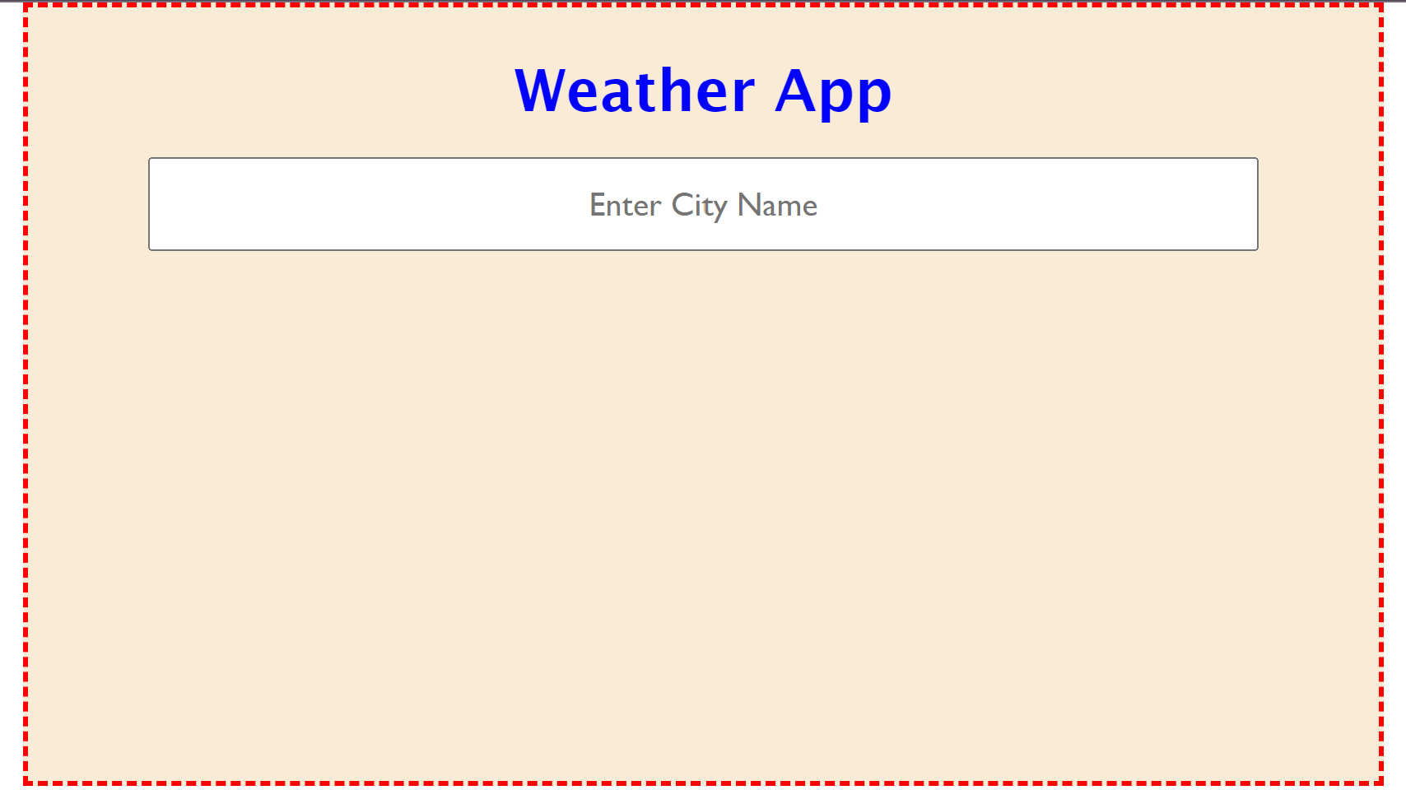

After the user enters a city name and presses the search button, the app should display the weather details of that city, as shown below:

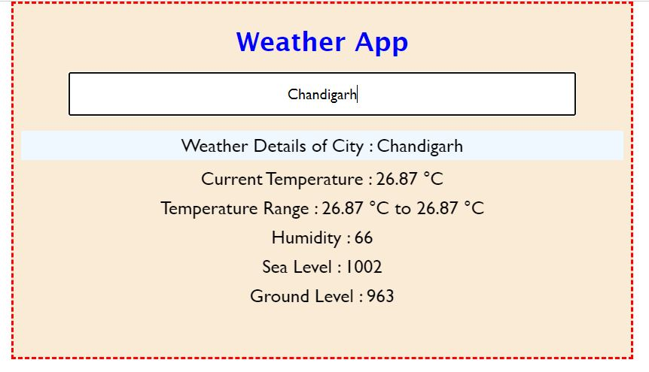

### **Test Cases -**

| Test Case 1 : Initially search bar should be empty with no last entries |
| --- |
| Test Case 2: Enter a valid city name and the details should automatically be updated. Verify that the weather details for that city are displayed, including temperature, humidity, sea level and ground level. |
| Test Case 3 : Enter an invalid city name. It should prompt the user to display a valid city name.    For details on verification of city name you can refer to below documentation  <https://openweathermap.org/current> |
| Test Case 4 : When Search bar is empty, the user prompt should also be empty    And last 3 valid city entries should still be visible in last-city-entries section |

**Submission Steps:**

1. Create a folder named `weather_app_assignment`
2. `weather_app_assignment` should contain Two Folders and 1 file
   1. Public folder
   2. src folder

Additionally make sure your project contains both

* package.json
* Image folder containing Screenshot of final output

And make sure node_module folder doesn’t exist in your

1. Compress your folder into a zip file and submit it.

You can use the document below as a guide to learn how to zip a folder and how to submit it in a feedback form : [Steps for submitting in a Feedback Form](https://docs.google.com/document/d/1wLV5j5eNMfY5GQ05R6ApCdqOEkb-1gbIALb3QYEWLJk/edit?usp=sharing)